 CHEMICAL ENGINEERING TRANSACTIONS  VOL. xxx, 2025 | A publication of  
The Italian Association
of Chemical Engineering
Online at www.cetjournal.it

Guest Editors: Fabrizio Bezzo, Flavio Manenti, Gabriele Pannocchia, Almerinda di Benedetto
Copyright © 2025, AIDIC Servizi S.r.l.
ISBN 979-12-81206-17-5; ISSN 2283-9216

Heptafluorobutyronitrile (C₄F₇N), hydrolysis, A Density Functional Theory (DFT) investigation
Muhammad Bilal Arifª, Christophe Coqueletª*, Frank Jacquier^{b}*, Carlo Adamo^{c}*, Maxime Lacuve^{b}*, Rachel Calvetª*
ªIMT Mines, ALBI, France
^{b}GE VERNOVA, Grid Solutions, Villeurbanne, France
^{c}PSL Chimie ParisTech, Paris, France

muhammad.arif@mines-albi.fr, christophe.coquelet@mines-albi.fr; frank.jacquier@ge.com; carlo.adamo@chimieparistech.psl.eu; Maxime.LACUVE@ge.com; rachel.calvet@mines-albi.fr
Heptafluorobutyronitrile (C₄F₇N) has received much consideration as an effective substitute to sulfur hexafluoride (SF₆) in the electrical industrial sector over the last decade. However, liability is the key to emerging technology, and the thermoelectric aging of the insulation gases may produce unavoidable consequences that raise concerns for the operator and human safety. Recently, numerous pieces of literature mentioned the production of crystals in the form of amide and dimer (ligand) generated from the aging of C₄F₇N with few water molecules. It was found that the hydrolysis of fluoronitrile chemical reactions initial with the production of amide (C₄H₂F₇NO) and following, with the addition of C₄F₇N molecules, accelerates the reaction to produce dimer (C₈H₂F₁₄N₂O) and further is the possibility to generate various range of byproducts. Thermodynamically, C₄F₇NH₂O + C₄F₇N C₈H₂F₁₄N₂O is the favourable chemical reaction with a 23 kcal/mol energy barrier that generates a dimer molecule. Furthermore, in presence of paramagnetic ion (typically Cu (II)), a Cooper based complex (as purple crystals) may appear. Gibbs free energy at elevated temperature indicates the driving force is needed to accelerate the reaction except C₈H₂F₁₄N₂O + H₂O C₁₂H₂F₂₁N₃O, whose energy values throughout remain consistent. Theoretical calculations reveal the water acts as a strong catalytic that can abruptly reduce the energy barrier of the initial reaction from 59 to 10 kcal mol⁻¹ and open the pathway to generate other byproducts.
  - Introduction
SF₆ is a well-known insulation gas, having the properties of excellent dielectric strength, arc quenching capability, chemical inertness, and low toxicity. These essential properties enable it an excellent choice to be used in high-voltage equipment such as Gas-Insulated Switchgear (GIS), Gas-Insulated Lines (GIL), Gas Circuit Breakers (GCB), Live Tank Breakers (LTB), and Dead Tank Breakers (DTB) from the past few decades. However, it has a global warming potential (GWP_{100-yr}) about 23,500 times that of CO₂ with a 3200-year lifetime. Thus, it was restricted to be used in high-voltage equipment worldwide in the 1997 Kyoto Protocol and labelled as one of six global warming potential gases (Dervos and Vassiliou, 2000). Therefore, scientists conducted extensive research work to figure out the substitution of SF₆ gas, and eventually, a buffer gaseous blend containing CO₂ and O₂ with a few percent of C₄F₇N was introduced in the market by GE VERNOVA, Grid Solution (Kieffel et al., 2017). Adding C₄F₇N in sufficient quantity will permit to have a bubble point curve in the right domain of P and T in comparison to CO₂/O₂ binary system.

Chemical stability of the insulation gas with the interaction of metals and humidity is the crucial factor for its usage in high-voltage devices. Several literatures mention the qualitative and quantitative studies regarding the byproduct’s identification under the thermoelectric stress of a g³ (C₄F₇N – CO₂ – O₂) gaseous mixture (Iddrissu et al., 2021), (Li et al., 2020), (Zhang et al., 2019), (Ye et al., 2022). Some common byproducts, CF₄, C₂F₆, C₃F₈, CF₃CN, C₂F₅CN, and COF₂, are identified by GC-MS and FTIR technology in different concentrations of g³ gaseous blend. However, the interaction of fluoronitrile (C₄F₇N) with water results in distinct byproducts and points out the various kinds of crystals after the aging for a certain period.

Recently, Siemens Energy (JUHRE et al., 2023) and Hitachi Energy (Donzel et al., 2024) conducted the experimental study to deeply understand the crystal generation phenomena with fluoronitrile and humidity and also explore the catalytic effect of various kinds of desiccants. Different shapes of crystals, including amide and dimer, are noticed at the end of long-term tests in GIS/GIL with a g³ gas mixture. Donzel et al., (2024) (Donzel et al., 2024) confirmed the melting points of amide (flakes-like crystals) and dimer (needle-like crystals) are 53 °C and 136 °C, respectively, by DSC measurement. Instead of removing or minimizing the humidity in the system, the desiccant also acts as a catalyst to accelerate the growth of crystals. Gao et al., (2022) (Gao et al., 2022) and his team proposed the 4 Å organic desiccant (CAS: 70955-01-0 ) as an alternative over the zeolite; though, experimental study close to industrial condition is still needed to benchmark the desiccants. Apart from the experimental work, Berteloot et al, state the chemical reaction mechanism of fluoronitrile hydrolysis in which different kinds of byproducts are generated, including amid (C₄H₂F₇NO) and dimer (C₈H₂F₁₄N₂O), molecules (Berteloot et al., no date). Additionally, some initial reactions are also specified in the Siemens Energy CIGRE 2022 paper (JUHRE et al., 2023).

In this study, we conduct a comprehensive simulation of the C₄F₇N hydrolysis reactions using Density Functional Theory (DFT), analyzing, and comparing the Gibbs free energy (∆G) for the reactions involved in the mechanism. The role of water molecule increments affecting the energy barrier in the amide formation process is explored. Additionally, temperature influence up to 3000 K on the Gibbs free energy (∆G) represent as energy barrier is estimated.
  - Methodology

DFT is one of the most effective tools to provide approximate solutions to the Schrodinger equation, the fundamental equation of quantum mechanics that describes any given chemical system. All the density functional theory (DFT) calculations were performed at the M062X hybrid functional (Zhao and Truhlar, 2008) and the combination of 6-311+G(d,p) basis sets (Krishnan et al., 1980), (Cramer, 2004) for geometry optimization, employed in “Gaussian16” packages (www.gaussian.com). Stationary points were established as minima with zero imaginary frequency. Each transition state was confirmed by the presence of one imaginary frequency at the same theory levels as employed for geometry optimization. The intrinsic reaction coordinate (IRC) calculations were carried out to confirm each transition state (TS) connecting with the two associated minima in the proposed mechanism. All the calculations are computed in ambient conditions (298.15 K and 1 atm) without solvation effect.
  - Results and discussion
Figure 1 illustrates the DFT-assisted reaction mechanism of fluoronitrile hydrolysis processes in the potential energy surface (PES) profile, and Table 1 presents the chemical reactions with the Gibbs free energies values. The first step involved the generation of an imidic acid (isomers) and amides following the hydration and tautomerization reactions. The first reaction (Ra) step involved a nucleophilic attack by the water molecule on the protonated nitrile (-C≡N) group of the fluoronitrile molecule to overcome the energy barrier of 59.1 kcal/mol, which undergoes the formation of an amidic acid with exothermic 5.6 kcal/mol energy. The highest energy barrier among all the reactions is reaction Ra and termed as the rate-determining step. Subsequently, the second step (Rb) is the isomerization of imidic acid, involving proton migration with a 34 kcal/mol barrier height to form a corresponding amide molecule (C₃F₇CONH₂) with an overall exothermic energy of 13.4 kcal/mol, making it a more probable channel among all the hydrolysis reactions and also reported in the following literature (Yu and Wang, 2021), (Barbosa and Van Santen, 2000).
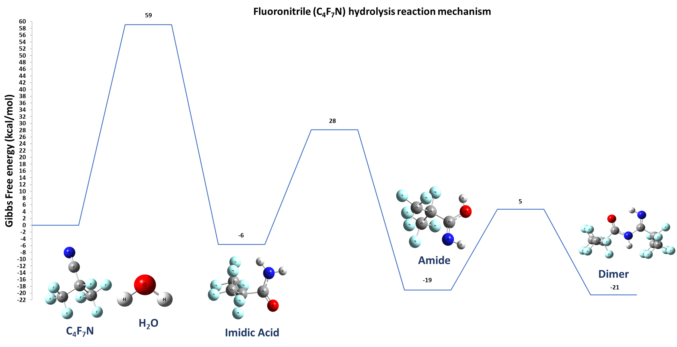
Figure 1: A complete chemical reaction mechanism of fluoronitrile hydrolysis

Consequently, the abundance of the C₄F₇N molecule in the system accelerates to the addition of another heptafluorobutyronitrile molecule and generates dimer. In the reaction (Rc), a dimer molecule is formed by the attack of a -CN bond from the fluoronitrile molecule on the -NH side of the amide, which needs an energy barrier of 23.8 kcal mol⁻¹. Lower energy barrier in (Rc), subjecting it to thermodynamically more favourable than (Rb), and resulting in the formation of needle-like shape as mentioned in Hitachi Energy thermal aging tests (Donzel et al., 2024). Additionally, these dimer molecules can trigger Cu-complex, a new violet crystal presented in the Kesseler study (Kessler et al., 2020).
Table 1: Absorbed energy and reaction barrier (kcal/mol) of fluoronitrile (C₄F₇N) hydrolysis reactions
# | Reactions symbol | Chemical Reaction | Relative Energy (kcal/mol) | Activation energy (∆G) (kcal/mol)
1 | Ra | C₄F₇N + H₂O C₄F₇NH₂O (tautomer) | -5.6 | 59.1
2 | Rb | (tautomer) C₄F₇NH₂O C₄F₇NH₂O | -13.4 | 33.8
3 | Rc | C₄F₇NH₂O + C₄F₇N C₈H₂F₁₄N₂O | -1.48 | 23.8

Another approach with the interaction of up to four water molecules reduces the energy barrier of the reaction Ra from 59.1 to 10 kcal/mol (Figure 2). Which implies the strong catalysing effect of water in the crystal’s generation phenomena. This suggests that the hydrogen bonding of the additional water molecules to the (C₃F₇CN-OH-H) reactant complex greatly promotes the addition processes of more than one water molecule. C₃F₁₀O (Xiao et al., 2017), NSCI (Zhen Guo, Cunyuan Zhao, David Lee Phillips, Evan G. Robertson, 2008), and aldehyde (Wang et al., 2018), molecules are also showing the same behaviour. These theoretical investigations suggest the strict removal and through-monitored humidity value in the circuit breaker to prevent any kind of crystal formation, ensuring human and device safety.
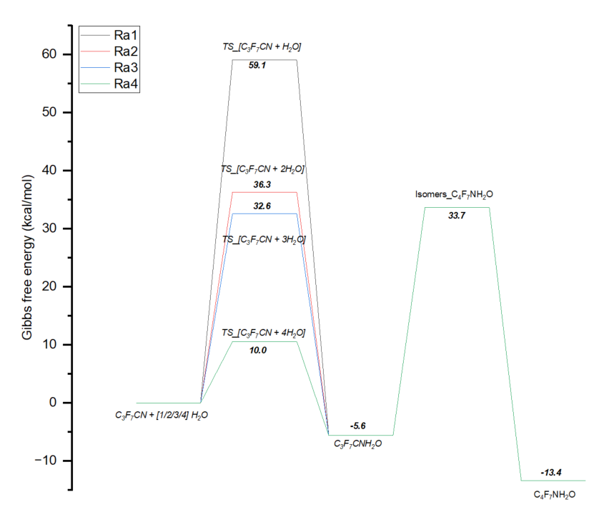
Figure 2: Reaction path of C₄F₇N with (n)H₂0 water molecule relative to the energy of
(-982,436603 a.u)

Temperature rises above ambient conditions during arcing in the circuit breaker; therefore, it should be considered to determine the free energy at a higher temperature. Figure 3 illustrates the relationship between the Gibbs free (∆G) energy within the temperature (K) range of 293 K to 3000 K through Gaussian thermochemistry data (Ochterski and Ph, 2000). All six chemical reactions have a Gibbs free energy value greater than zero, thereby implying that the fluoronitrile hydrolysis process cannot be carried out spontaneously. With the increment of temperature, the Gibbs free energy of reactions Ra, and Rb, abruptly decreases, while for reaction Rc, it remains consistently constant.
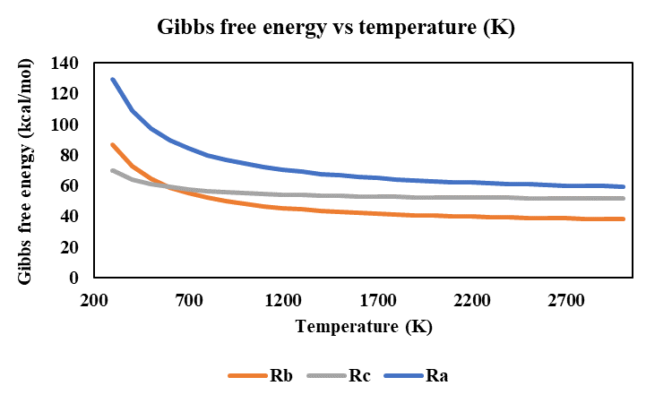
Figure 3: Variation of Gibbs free energy of fluoronitrile hydrolysis reactions under the influence of temperature (K)

  - Conclusion
In this study, a DFT-assisted theoretical study is conducted to explore the interaction between heptafluoroisobutryle (C₄F₇N) and water and compute six chemical reactions. MO62X hybrid functional with the combination of 6-311+G(d,p) basis sets was utilized to compute the chemical reaction. All the molecular geometry is optimized, and the transition state is confirmed by the presence of one imaginary frequency. Amid (C₄H₂F₇NO), and dimer (C₈H₂F₁₄N₂O) are the main molecules produced through the hydrolysis of fluoronitrile. Among all the six-chemical reactions, the reaction (Ra) is termed a rate-determining step with an energy barrier of 59.1 kcal/mol. The energy value suddenly dropped to 10 kcal/mol from 59.1 kcal/mol by the addition of four water molecules in the first chemical reaction, indicating the small quantity of water is enough to initiate the reaction. Gibbs free energy (∆G) in the temperature range from ambient to 3000 K, confirming that all the reaction is spontaneous except reaction Rd. The DFT-assisted study of fluoronitrile hydrolysis provided valuable insights into the reaction energies of all steps, advancing in the experimental design to optimize conditions and remove byproduct formation.

Acknowledgments
This work was financially supported by (Conventions industrielles de formation par la recherche) (CIFRE) and GE VERNOVA, Grid Solutions. Access to the theoretical software was graciously provided by PSL Chimie ParisTech.
References

Barbosa, L.A.M.M. and Van Santen, R.A. (2000) ‘A systematic study of the ancillary effect of different molecules on the acetonitrile hydrolysis’, Journal of Molecular Structure: THEOCHEM, 497(1–3), pp. 173–188. Available at: https://doi.org/10.1016/S0166-1280(99)00283-3.
Berteloot, T. et al. (no date) ‘LONG-TERM BEHAVIOUR OF C4-FN MIXTURES IN HIGH-VOLTAGE EQUIPMENT’, in General Electric.
Cramer, C.J. (2004) Essentials of Computational Chemistry. Second Edi.
Dervos, C.T. and Vassiliou, P. (2000) ‘Sulfur hexafluoride (sf6): Global environmental effects and toxic byproduct formation’, Journal of the Air and Waste Management Association, 50(1), pp. 137–141. Available at: https://doi.org/10.1080/10473289.2000.10463996.
Donzel, L. et al. (2024) ‘Chemistry of C4-FN gas mixtures and application in high-voltage equipment’, Conseil international des grands réseaux électriques (CIGRE) [Preprint].
Gao, W. et al. (2022) ‘Materials Compatibility Study of C4F7N/CO2Gas Mixture for Medium-Voltage Switchgear’, IEEE Transactions on Dielectrics and Electrical Insulation, 29(1), pp. 270–278. Available at: https://doi.org/10.1109/TDEI.2022.3146460.
Iddrissu, I. et al. (2021) ‘Gas decomposition and electrode degradation characteristics of a 20% C3F7CN and 80% CO2 gas mixture for high voltage accelerators’, High Voltage, (05), pp. 750–759. Available at: https://doi.org/10.1049/hve2.12120.
JUHRE, K. et al. (2023) ‘Long-term performance and decomposition of Fluoronitrile-containing gas mixtures in gas-insulated systems’, Conseil international des grands réseaux électriques (CIGRE), 124.
Kessler, F. et al. (2020) ‘Compatibility of a Gaseous Dielectric with Al, Ag, and Cu and Gas-Phase Synthesis of a New N-Acylamidine Copper Complex’, European Journal of Inorganic Chemistry, 2020(20), pp. 1989–1994. Available at: https://doi.org/10.1002/ejic.202000213.
Kieffel, Y. et al. (2017) ‘Characteristics of g3 - An alternative to SF6’, in CIRED - Open Access Proceedings Journal. Institution of Engineering and Technology, pp. 54–57. Available at: https://doi.org/10.1049/oap-cired.2017.0795.
Krishnan, R. et al. (1980) ‘Selfconsistent molecular orbital methods. XX. A basis set for correlated wave functions’, Citation: J. Chem. Phys, 72, p. 650. Available at: https://doi.org/10.1063/1.438955.
Li, Y. et al. (2020) Influence regularity of O2 on dielectric and decomposition properties of C4F7N–CO2–O2 gas mixture for medium-voltage equipment, High Voltage. Institution of Engineering and Technology. Available at: https://doi.org/10.1049/hve.2019.0219.
Ochterski, J.W. and Ph, D. (2000) ‘Thermochemistry in Gaussian’, Gaussian Inc Pittsburgh PA, 264(1), pp. 1–19. Available at: https://doi.org/10.1016/j.ijms.2007.04.005.
Wang, X.Y. et al. (2018) ‘Do two oxidants (ferric-peroxo and ferryl-oxo species) act in the biosynthesis of estrogens? A DFT calculation’, RSC Advances, 8(27), pp. 15196–15201. Available at: https://doi.org/10.1039/c8ra01252k.
www.gaussian.com (no date) No Title.
Xiao, S. et al. (2017) ‘Effects of micro-water on decomposition of the environment-friendly insulating medium C5F10O’, AIP Advances, 7(6). Available at: https://doi.org/10.1063/1.4990512.
Ye, F. et al. (2022) ‘Arc decomposition behaviour of C4F7N/Air gas mixture and biosafety evaluation of its by-products’, High Voltage [Preprint]. Available at: https://doi.org/10.1049/hve2.12233.
Yu, X. and Wang, B. (2021) ‘Mechanistic Insight into the Decomposition of Eco-Friendly Dielectric Gas Heptafluoro-iso-butyronitrile in the Presence of Water Impurity’, IEEE Transactions on Dielectrics and Electrical Insulation, 28(4), pp. 1273–1281. Available at: https://doi.org/10.1109/TDEI.2021.009608.
Zhang, B. et al. (2019) ‘Decomposition characteristics of C4F7N/CO2 mixture under AC discharge breakdown’, AIP Advances 9 [Preprint]. Available at: https://doi.org/10.1063/1.5115588.
Zhao, Y. and Truhlar, D.G. (2008) ‘The M06 suite of density functionals for main group thermochemistry, thermochemical kinetics, noncovalent interactions, excited states, and transition elements: two new functionals and systematic testing of four M06-class functionals and 12 other function’, Theoretical Chemistry Accounts, 120, pp. 215–241. Available at: https://doi.org/10.1007/s00214-007-0310-x.
Zhen Guo, Cunyuan Zhao, David Lee Phillips, Evan G. Robertson, and D.M. (2008) ‘An Experimental and Theoretical Study of NSCl Decomposition in the Presence of Trace Amounts of Water’, The journal of physical chemistry. A, 112, pp. 8561–8568.

